LAB 6

The lab Has been performed in vlab.

wireless-‐lab-‐capture.cap file has been downloaded from the link 10.12.1.10/pcap as shown below.
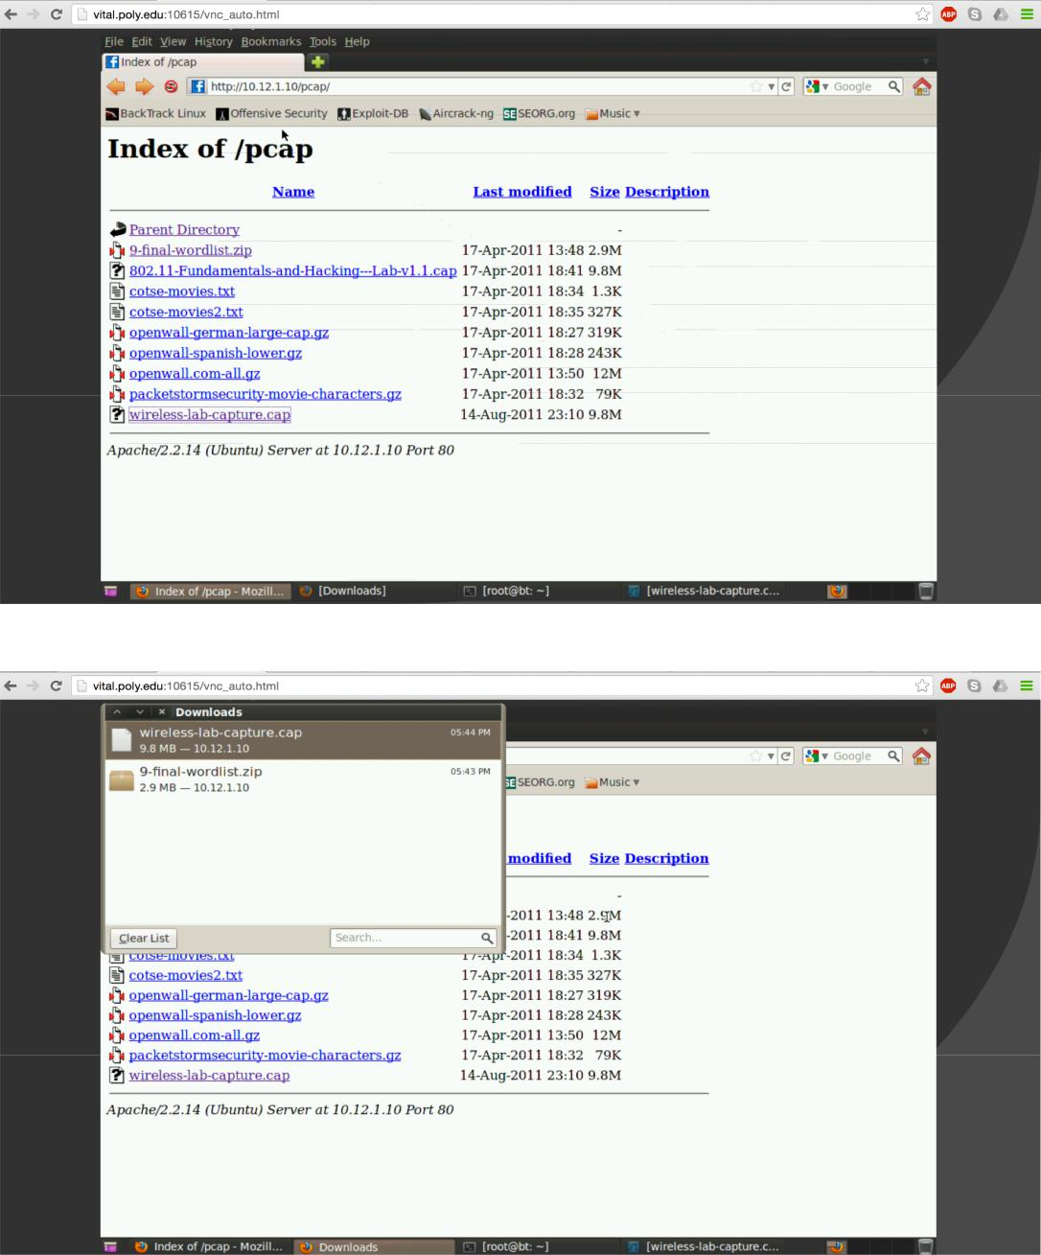

AIM is the plaintext communication protocol used.
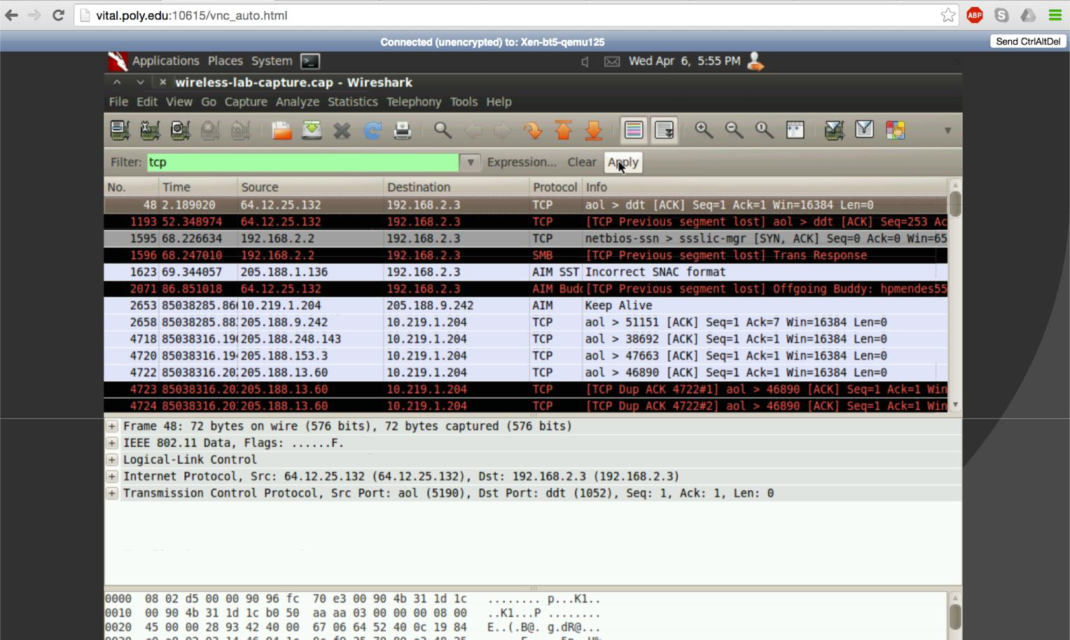

Conversation is about twin galaxy servers.
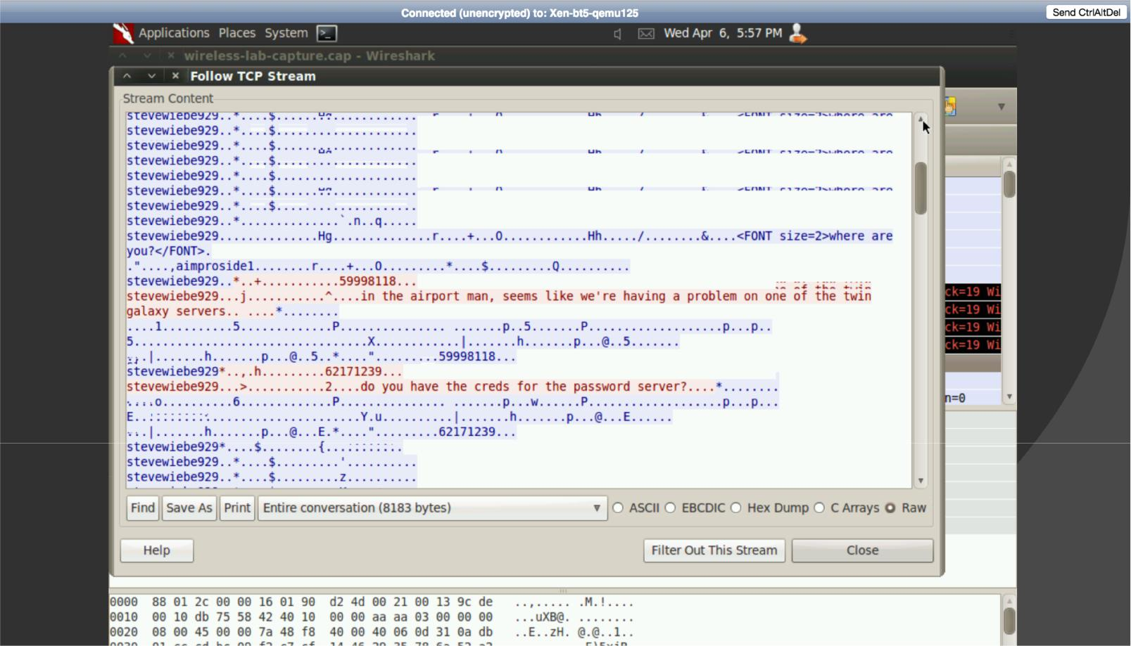

Username is sysadmin
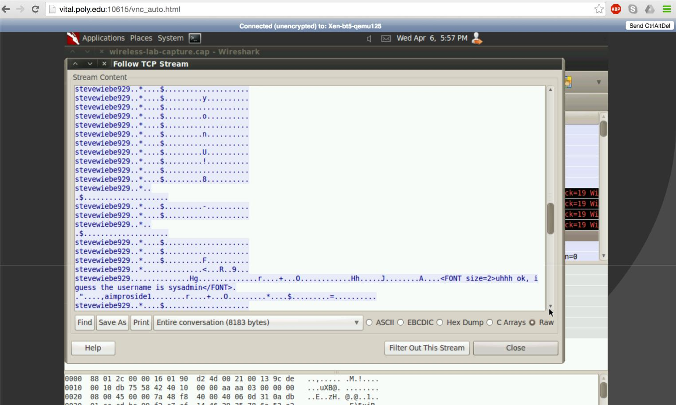

Password is B!lliesux0rz.steveis.king
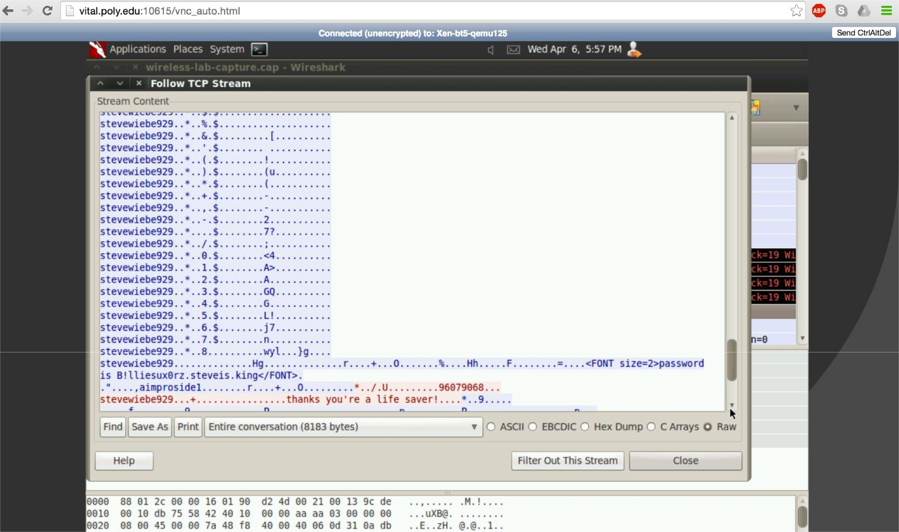

First I studied aircrack-‐ng command from the link provided. Command used: aircrack-‐ng –z wireless-‐lab-‐capture.cap
-‐z option invokes the WEP cracking method.
WEP key: [FB:83:5B:A0:51:B5:82:DF:BB:2D:DE:DE:E1]
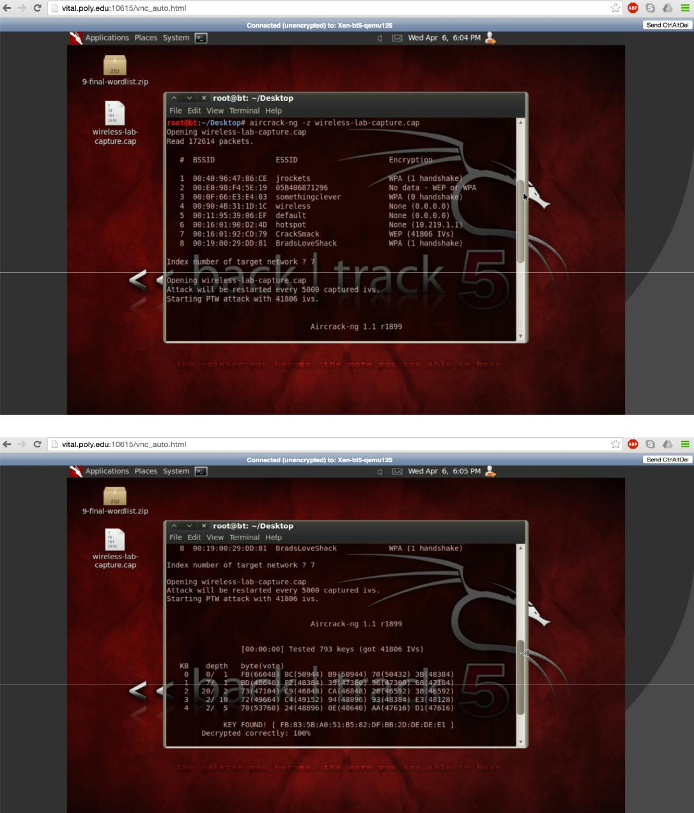

Pre-‐shared key: absentminded File used: final-‐wordlist.txt Time to crack the key: 40 secs
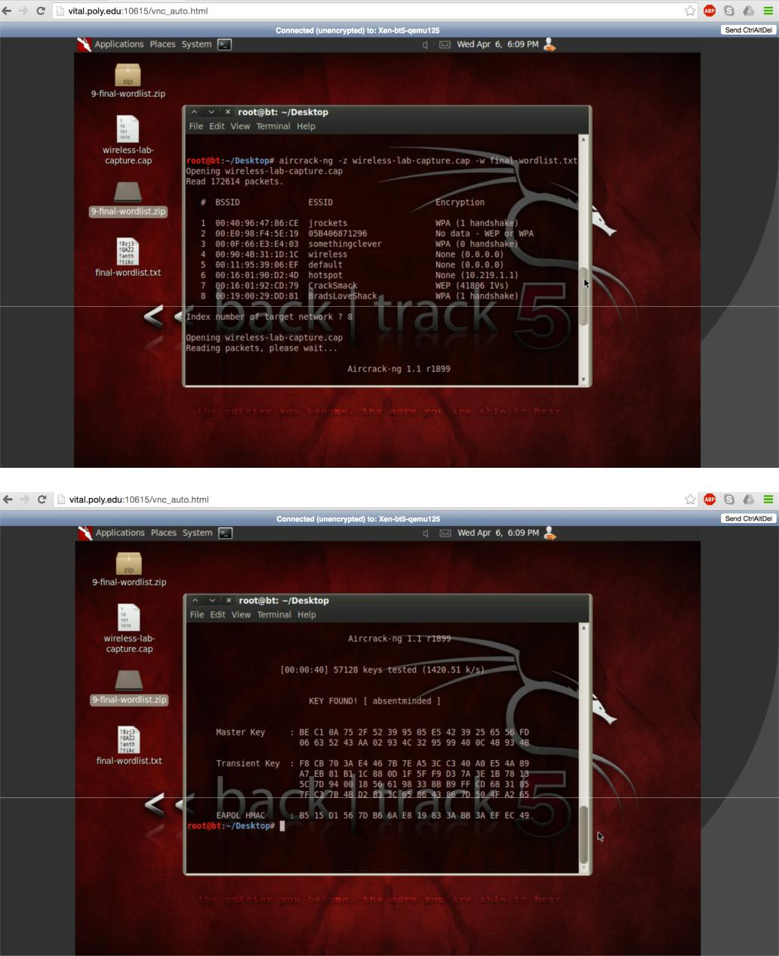

First we gunzipped the file openwall.com-‐all.gz which was downloaded from link 10.12.1.10/pcap.

Command used: gunzip openwall.com-‐all.gz
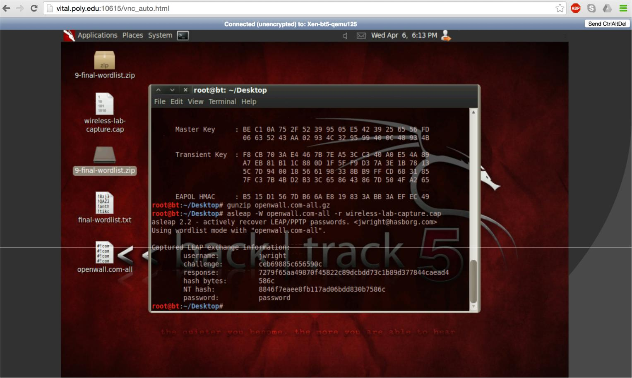
To find the password command used: asleap –W openwall.com-‐all –r wireless-‐lab-‐capture.cap Password: password

